Record Triggered Flow 28.06.22

Flow 1. Create Contract Under Same Account

Requirement 1.

* Tamara McCleary is working as a System Administrator at Universal Containers (UC). At UC they are using Salesforce to manage their Contracts. Salesforce allows you to create a Contract for an Account. Whenever an Opportunity is successfully closed (Stage: – Closed Won), auto-create a new Contract and activate it. Also, set the following fields
* Contract Start Date = Close date of current Opportunity
* Contract Term (months) = 12.

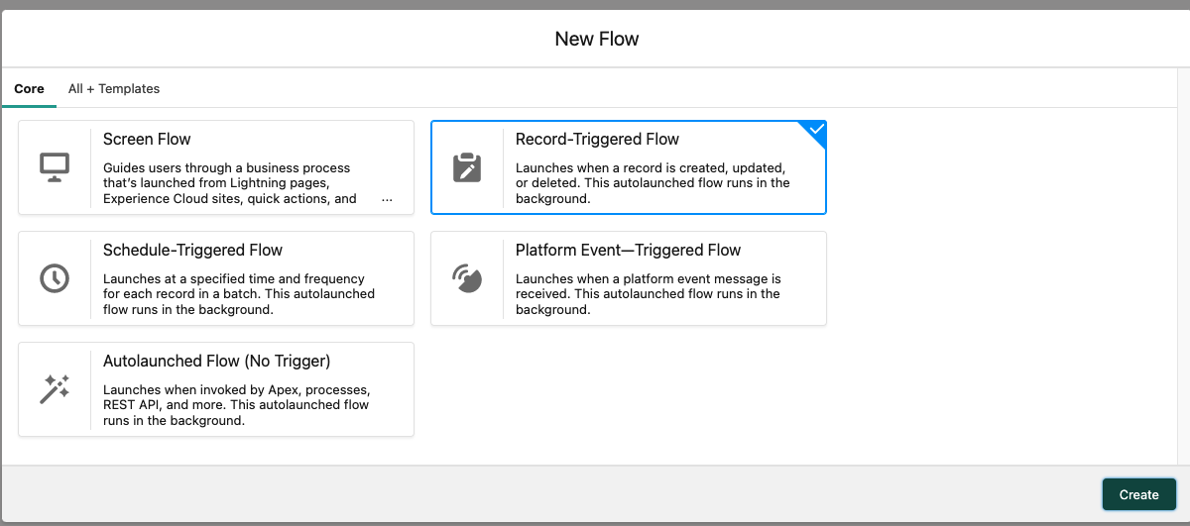

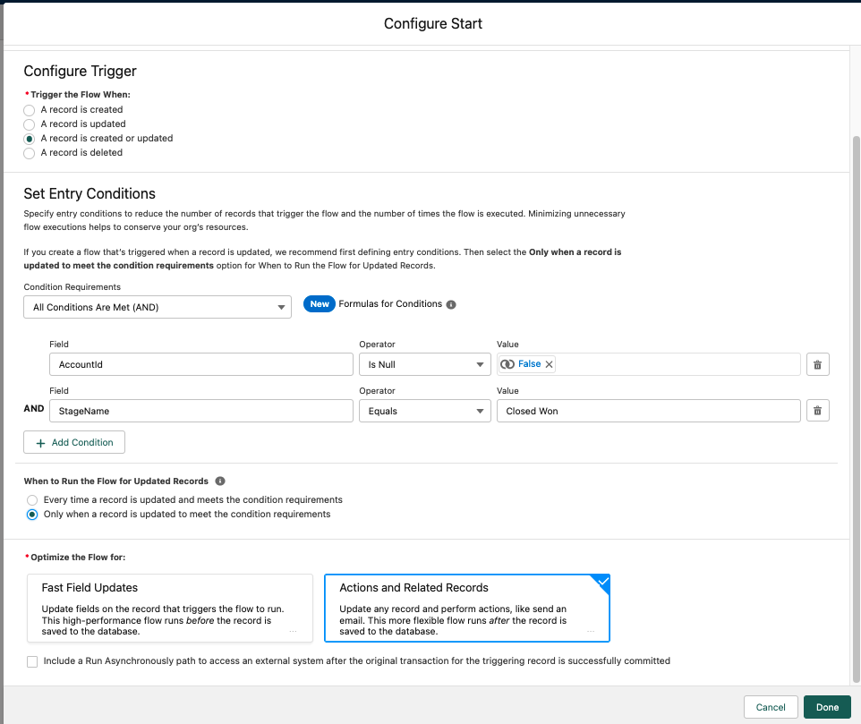

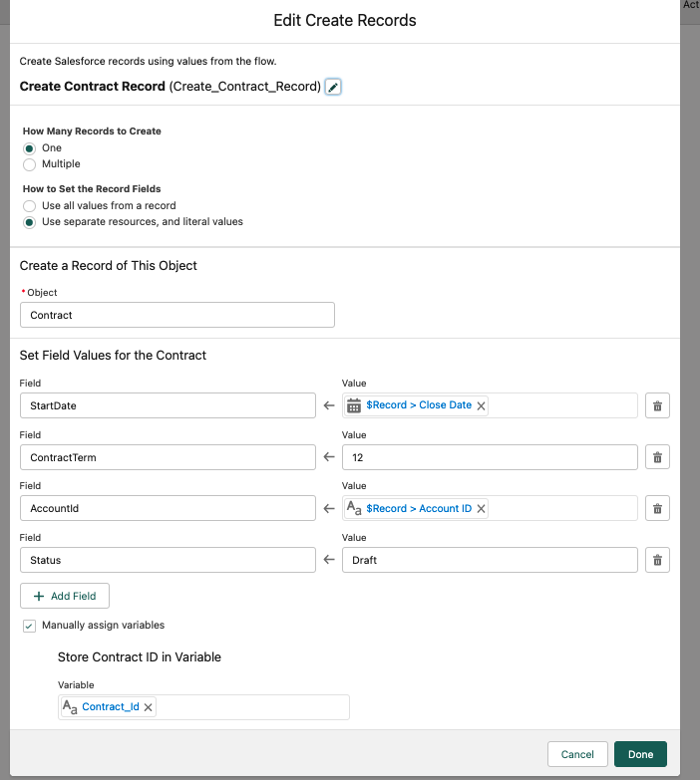

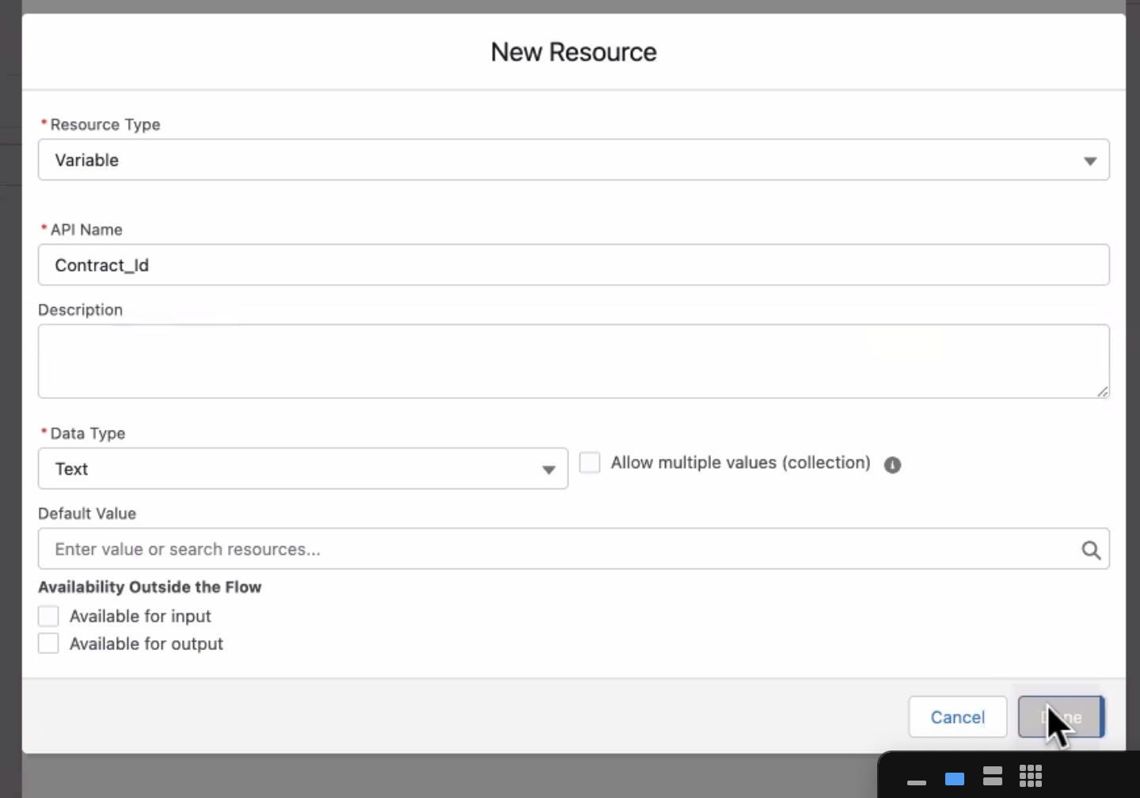

( 1.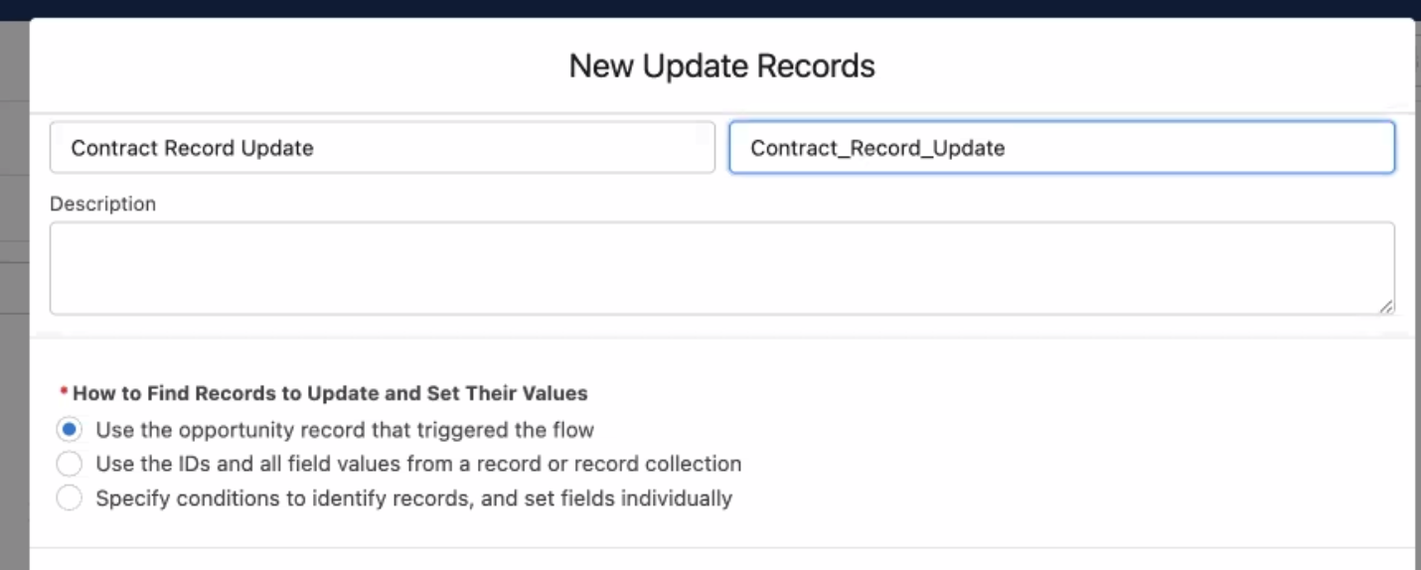

For update the same object

2.

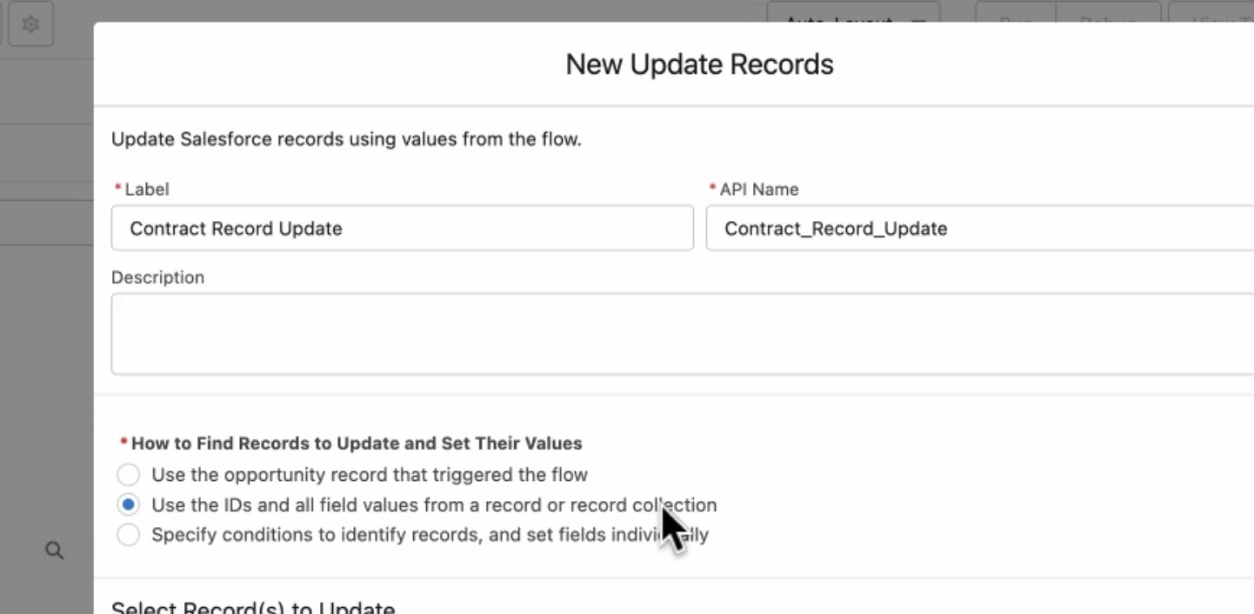

When i want get

3.

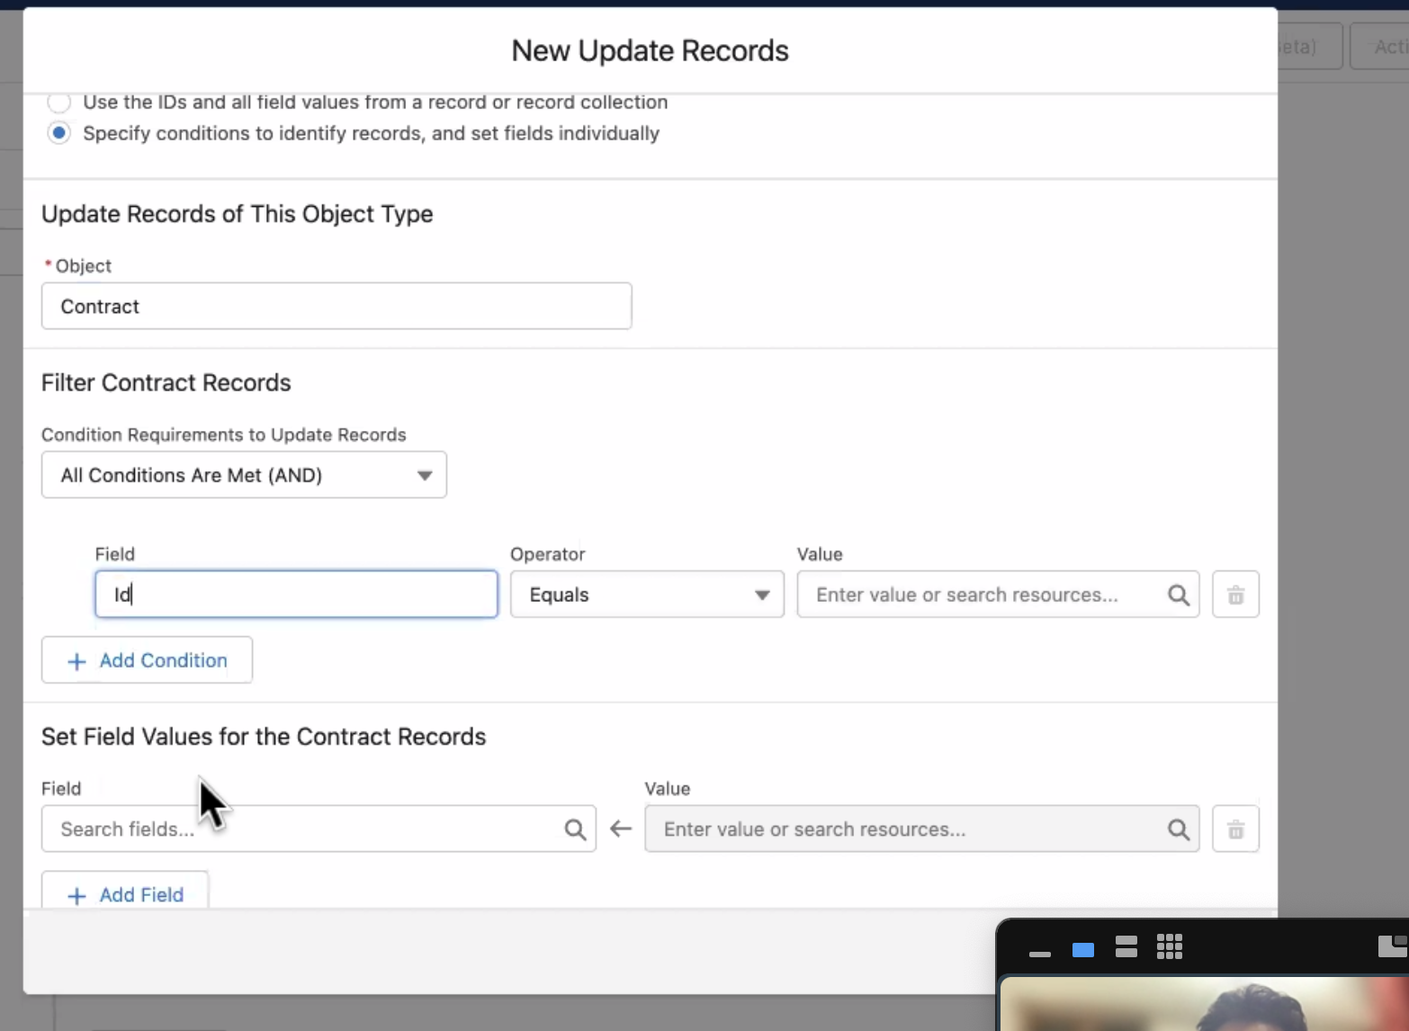

It gets me liberty to select an object . )

Soooo:

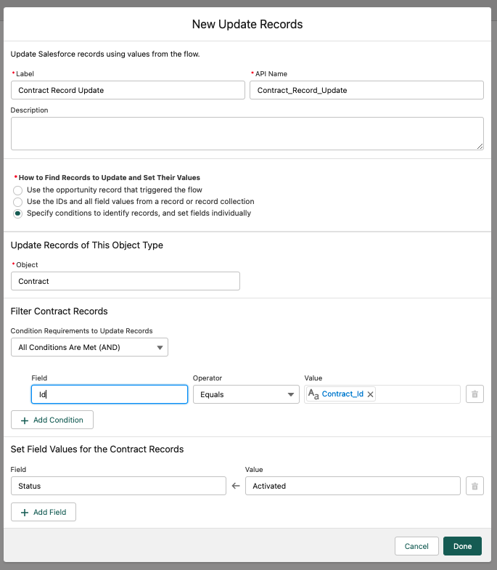

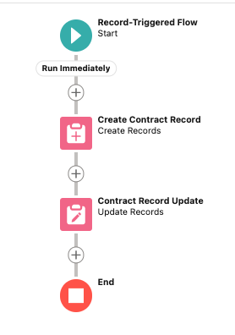

Requirement 2 Flow 2: Create Clone Opportunity

Steve Cartwright is working as a System Administrator at Universal Containers (UC). He received a requirement to auto-create a new Opportunity (Similar to an old record) whenever an Opportunity is successfully closed with the following details:

Set the Close date for the new Opportunity to 365 days ahead of old Record closed date

Opportunity Name

Stage = Prospecting

DEMO:

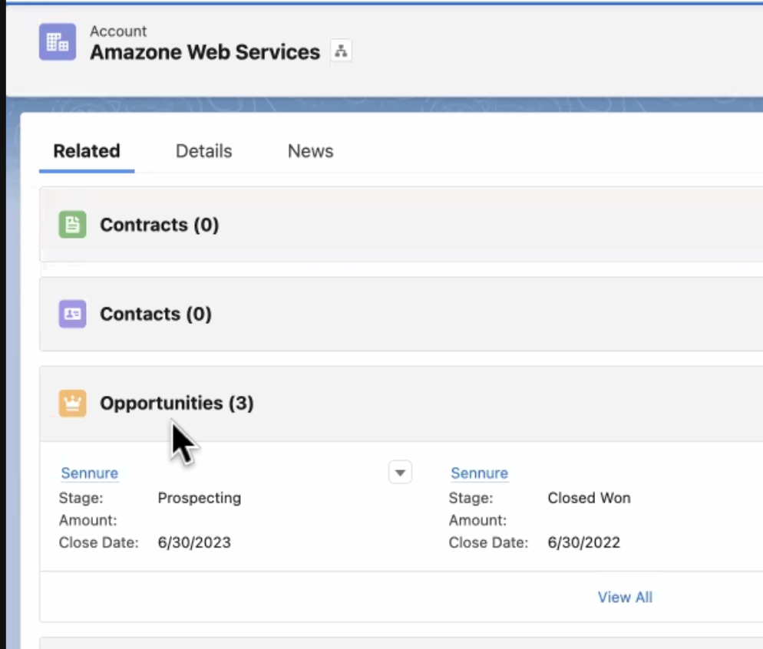

—---

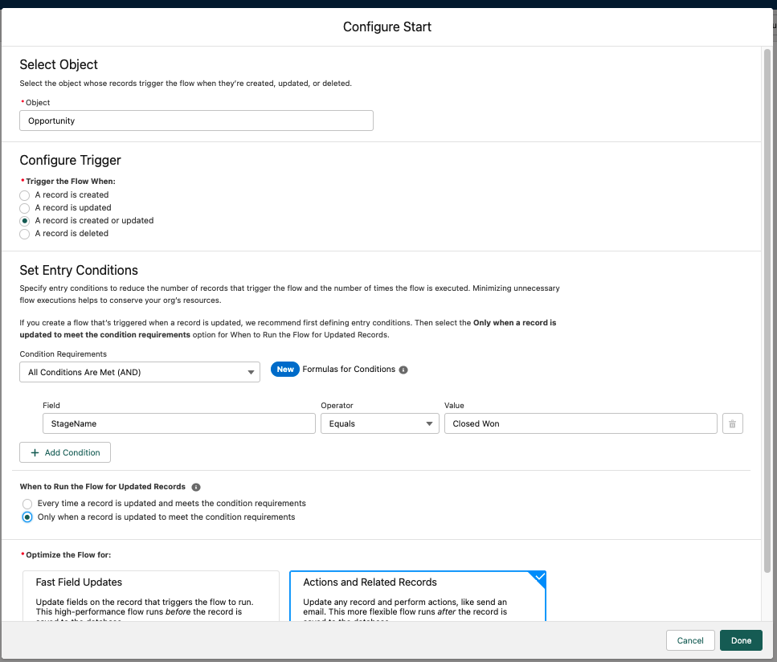

(Before trigger→ Field Update on same object and Validation) So it isn't my case.

CREATE CLONE RECORD:

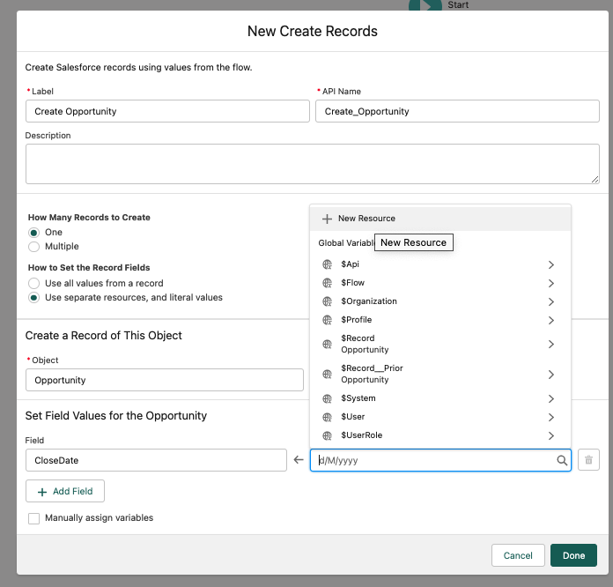

Create Formula variable

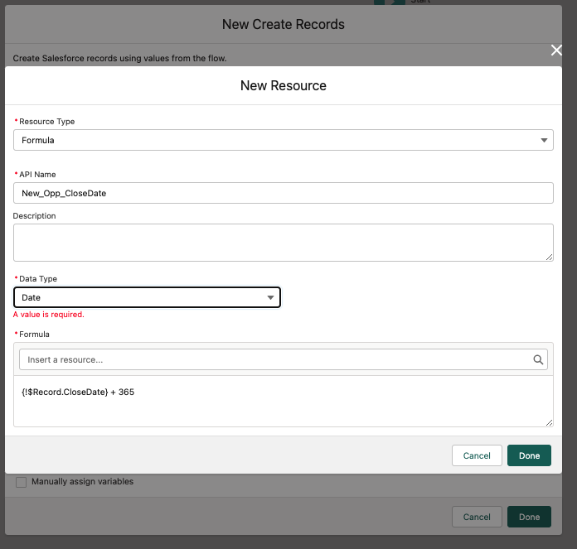

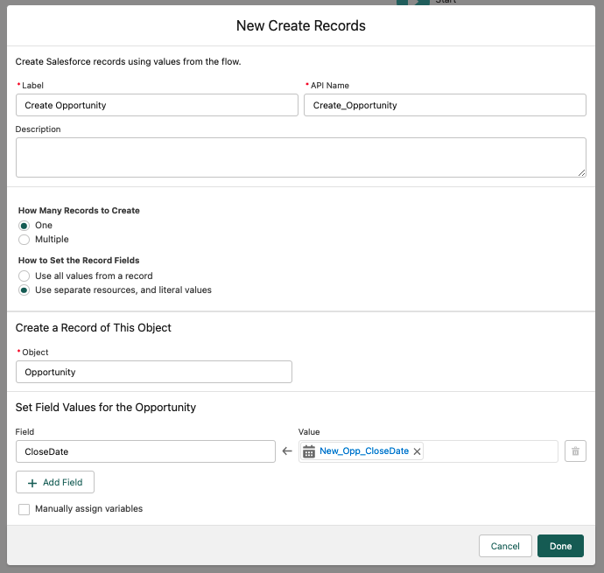

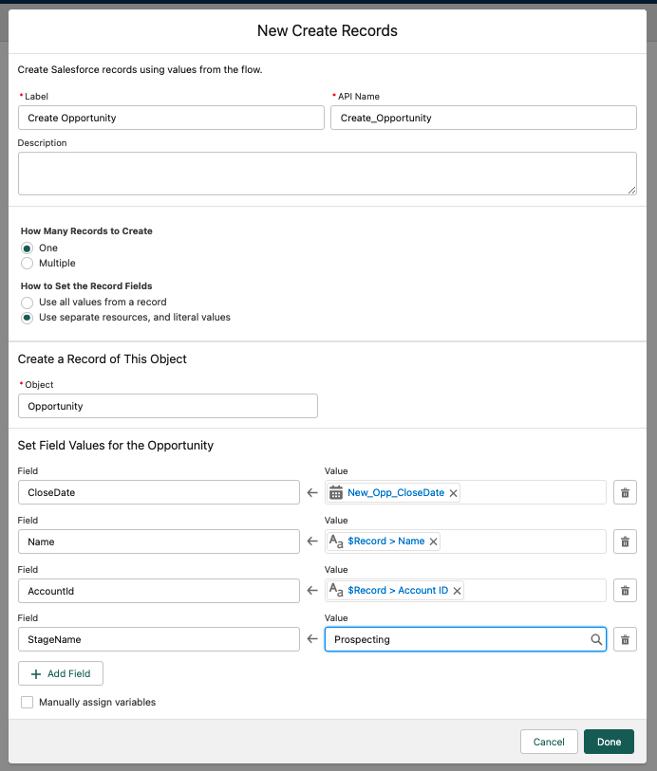

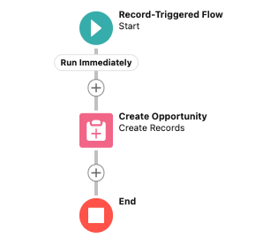

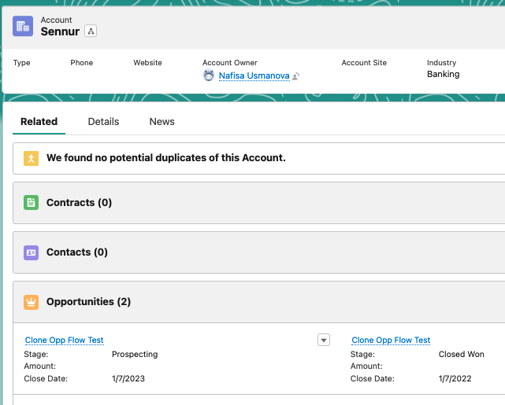

FLOW 3: Update Quotes Status to Denied

Tamara McCleary is working as a System Administrator at Gurukul on Cloud (GoC). They use Salesforce to manage Opportunities and Quotes, and each Opportunity can have multiple Quotes. Whenever a customer accepts a Quote, all other Quote records related to that opportunity should have the Status updated to Denied.

Quote object is child object of Opportunity. By default It is not in SF org. It is part of CPQ.

To enable it go to Setup.

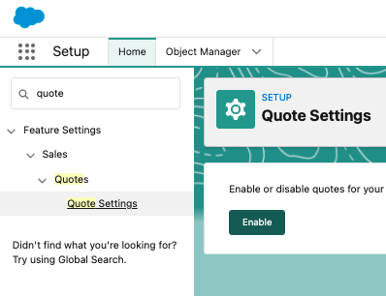

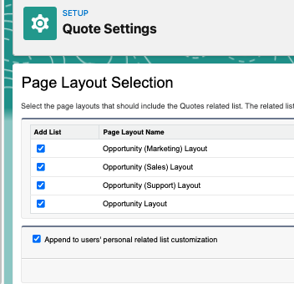

Opps- Deals information

Acc -person who pay

Cont - customer info

Lead - store prospect info Potential customer

Quote - Multiple billings

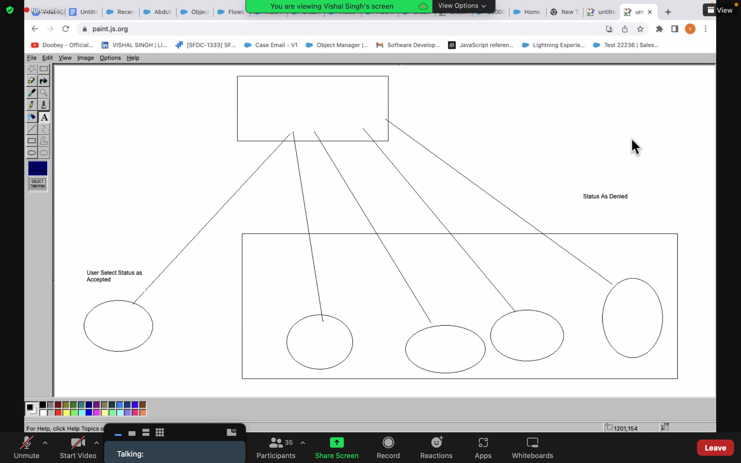

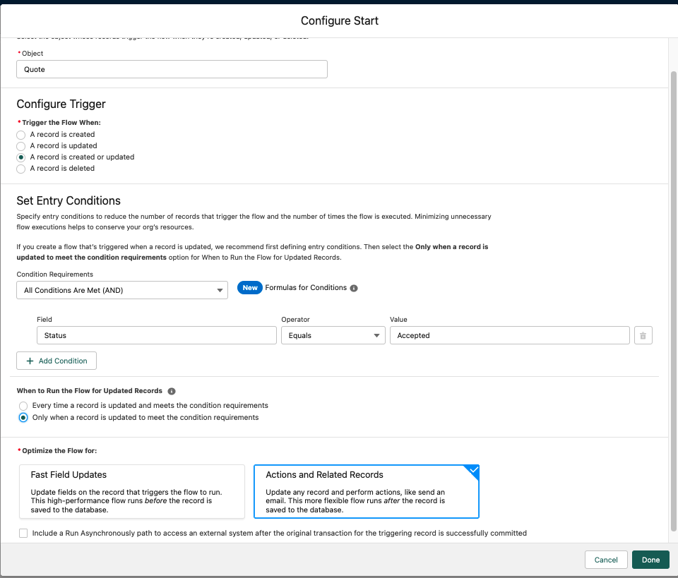

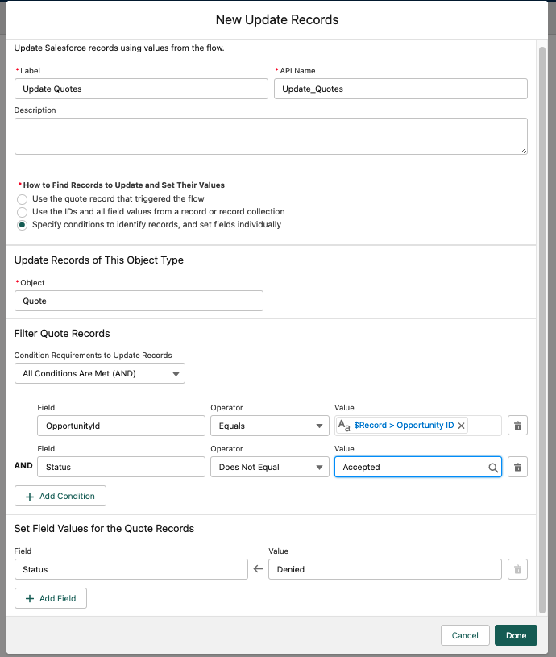

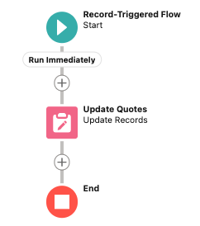

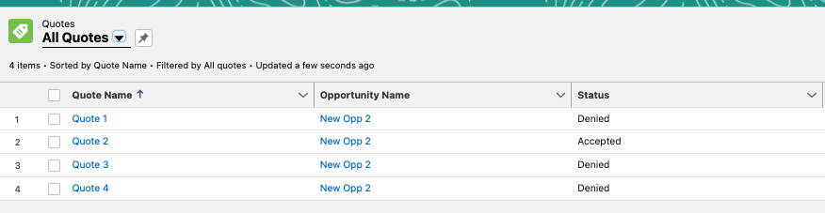

FLOW 4: Create Child Case

Corey Eridon is working as a System Administrator at Gurukul on Cloud (GoC). He received a requirement to build a flow that would automatically create a child case whenever a new case is created with the Case Reason – Breakdown.

* Add Parent Case field in Case Detail Page:

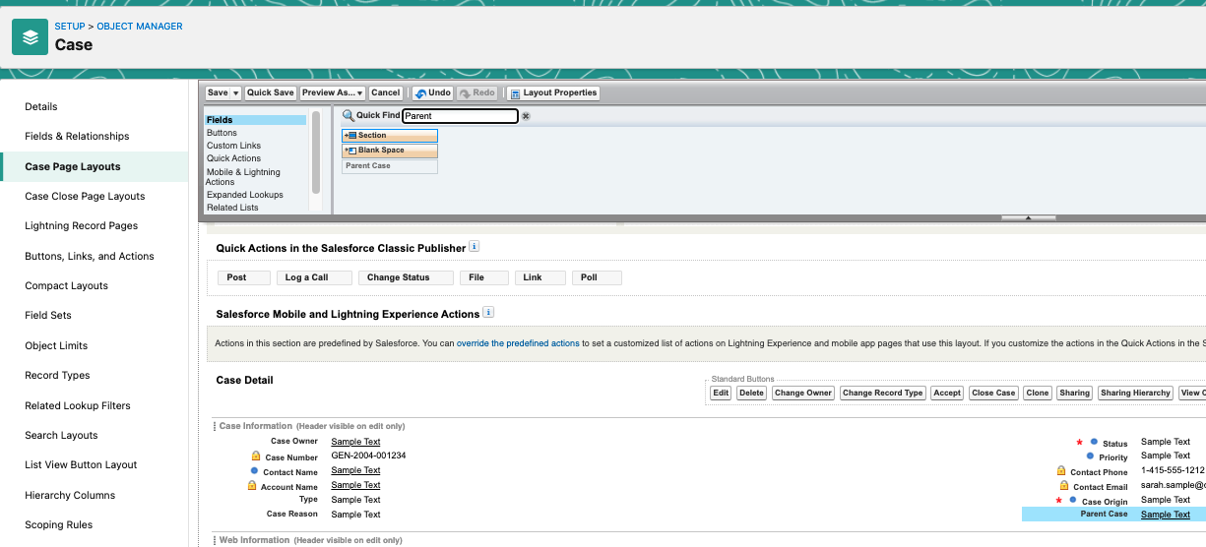

* Rec Trig Flow:

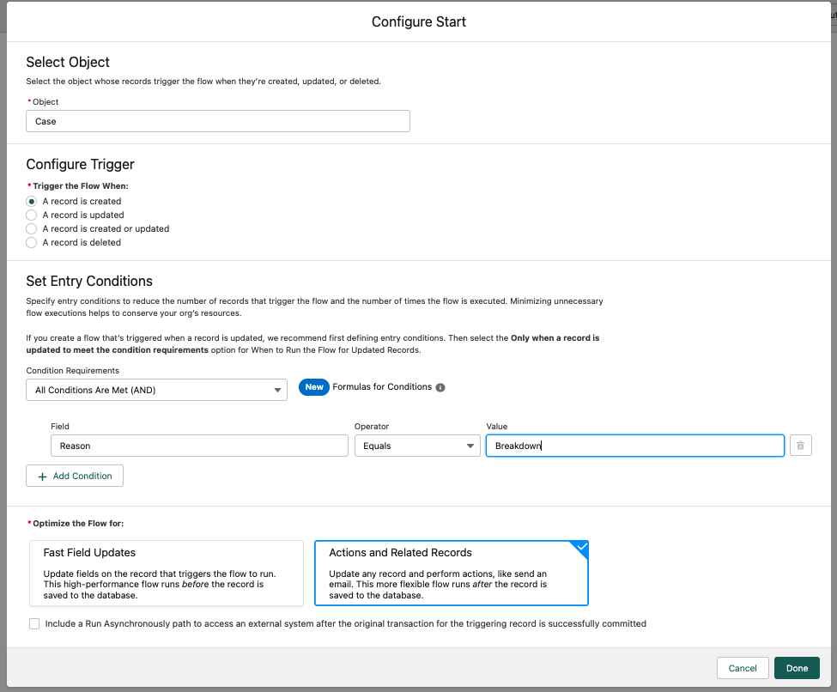

* Create new child case

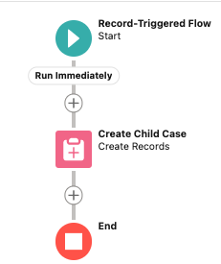

TADA!!!

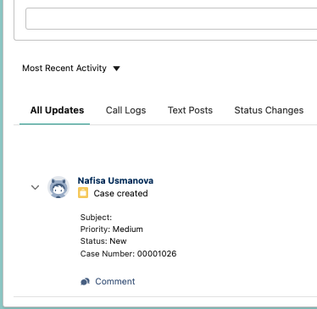

FLOW 5 : Conditional Update on Contact and Opps ​​

Whenever Account Annual Revenue field gets updated then the same value must be updated to its all child opportunity Amount Field with the same value and if Account description gets updated then the same description must be updated to its all child contact description.

1A) (Seyma hocam Bu 1A kismina sen bakma)

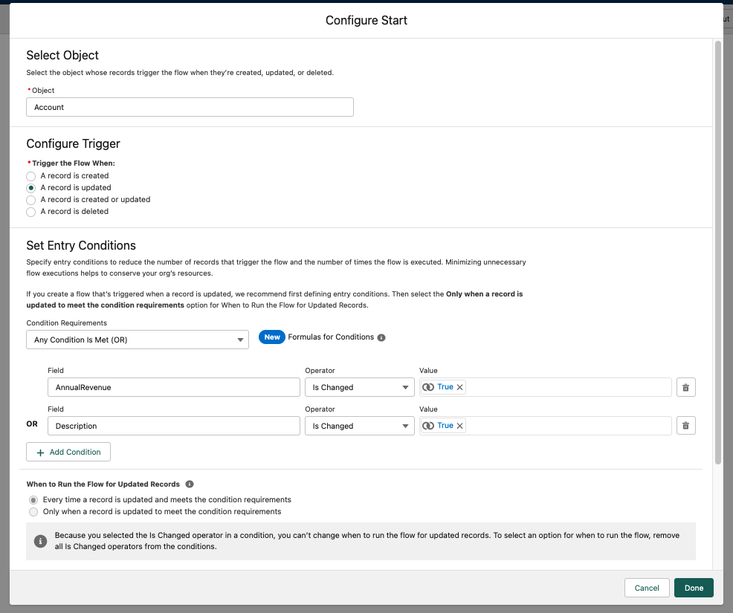

Bu Conditionda Default hic bir zaman execute olmayacak. Cunki en basta iki sart belirledik.

OOOOOR… (None + Decision) :

1B)

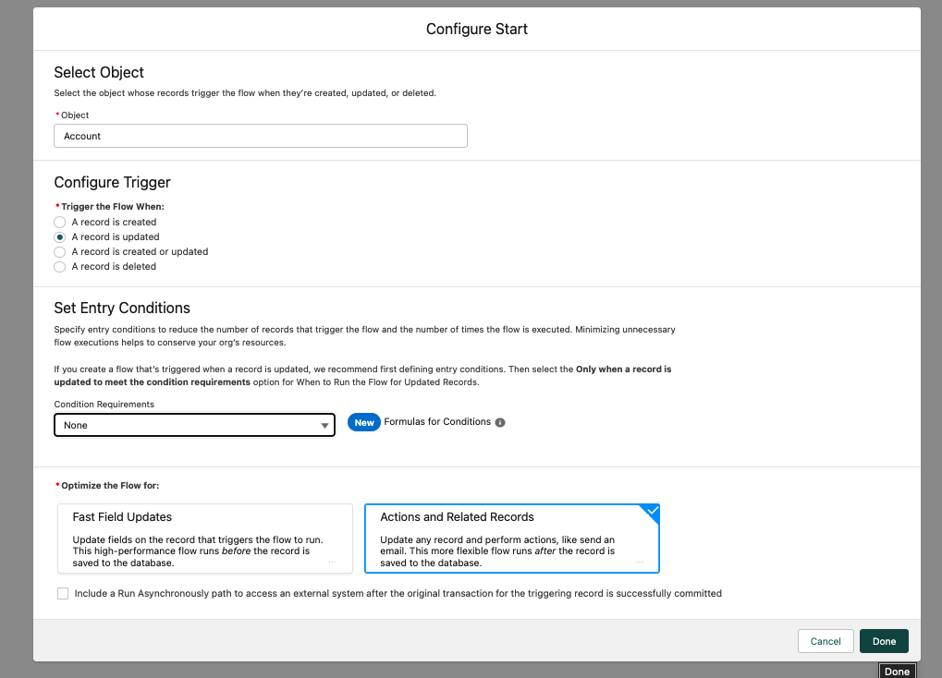

* Decision..

